2022

April

COMMUNICATIONS TOOLKIT
To Promote the April 1, 2022
10TH “Birthday” of the Medicare Shared Savings Program!
#HappyBirthdayMSSP

April 2022 marks the 10-year anniversary of the start of the Medicare Shared Savings Program (MSSP). The first performance year (PY) of the MSSP began on April 1, 2012 and on April 10, 2012, the Centers for Medicare & Medicaid Services (CMS) announced the first 27 accountable care organizations (ACOs) to participate in the program. This first class of MSSP ACOs covered nearly 375,000 beneficiaries across 18 states. A decade on, the MSSP now includes 483 ACOs serving 11 million beneficiaries across all 50 states, Washington, DC, Puerto Rico and the U.S. Virgin Islands.
To celebrate MSSP’s 10th “birthday” and how much the program has grown in the past decade, we will be sharing program highlights and success stories throughout the month of April! You can celebrate with us by using this toolkit or creating your own posts with the hashtag: #HappyBirthdayMSSP. We also hope you will join us (in-person or virtually) at the NAACOS 2022 spring conference on April 27-29 to celebrate with ACOs from across the country, share lessons learned, and continue working to improve and advance accountable care! Below you will find sample posts for Twitter and LinkedIn, which you can modify for other communications channels, as well as sample graphics to include in these posts or share on their own to spread awareness and support for Medicare’s leading value-based care program:
Sample Twitter posts:
Join us & @NAACOSnews in celebrating the 10th year of the #MedicareSharedSavingsProgram this April! This month, we’re highlighting the program’s successes in providing high quality care to patients & advancing #valuebasedcare. Follow #HappyBirthdayMSSP to celebrate with us!

The 1st class of 27 #MedicareSharedSavingsProgram ACOs began participation on 4/1/2012. By 2020, MSSP included 518 ACOs saving $4.14 billion! From 2012-2020 MSSP ACOs saved $11.2 BILLION! ACOs are preserving the #MedicareTrustFund while improving quality! #HappyBirthdayMSSP

The average #MedicareSharedSavingsProgram quality score was 97.8 (/100) in 2020, a program high! Since the start of the program, MSSP ACOs have increased the average quality score by nearly 15 percentage points. All patients deserve better care at lower costs! #HappyBirthdayMSSP

We’re joining @NAACOSnews to say #HappyBirthdayMSSP this April! This important #valuebasedcare program has been improving care for patients and generating savings for the #MedicareTrustFund for a decade and continues to improve year-over-year! https://bit.ly/2020ACOresults

Sample LinkedIn posts:
April 2022 marks the 10-year anniversary of the start of the Medicare Shared Savings Program (MSSP). We’re joining the National Association of ACOs to say #HappyBirthdayMSSP! This important #valuebasedcare program has been improving care for patients and generating savings for the #MedicareTrustFund for a decade and continues to improve year-over-year! https://bit.ly/2020ACOresults
This April, we are saying #HappyBirthdayMSSP to celebrate the 10th “birthday” of the Medicare Shared Savings Program (MSSP). The first performance year of the program began with 27 ACOs on April 1, 2012. Today, the program includes 483 ACOs serving 11 million Medicare beneficiaries! Not only has the program generated $11.2 billion in savings, but the average quality score reached 97.8 (out of 100) in 2020. Learn more: https://bit.ly/2020ACOresults
Medicare Shared Savings Program (MSSP) ACOs have been working to improve quality and reduce health care costs since April 1, 2012. This month, we’re saying #HappyBirthdayMSSP to celebrate and share ACO success stories. Learn how ACOs are working to reduce gaps in #healthequity and address their patients’ social needs through data analytics and care coordination: https://bit.ly/ACOhealthequity
Sample graphics to share:

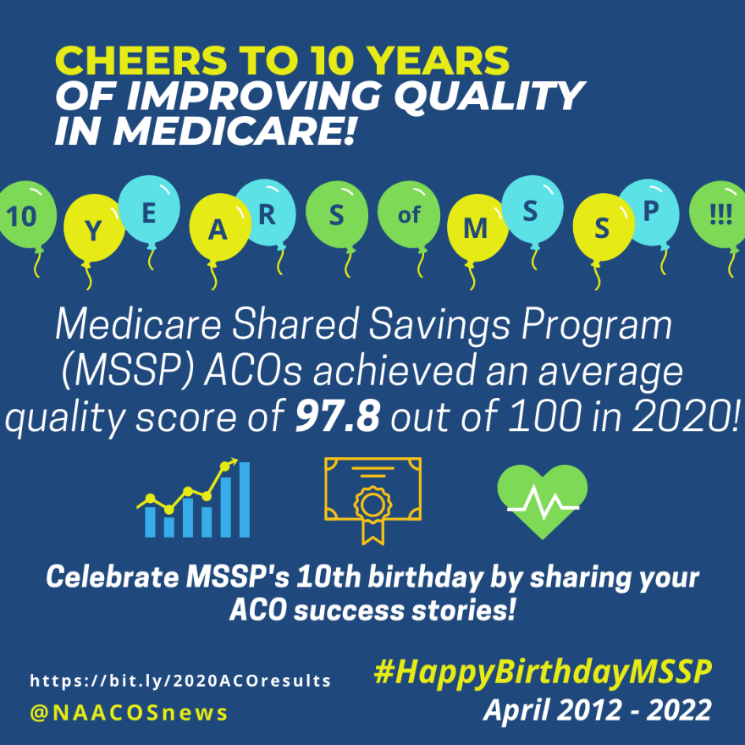
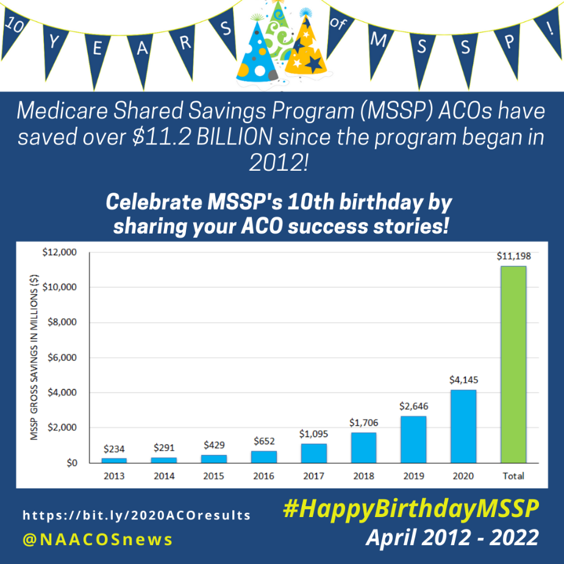
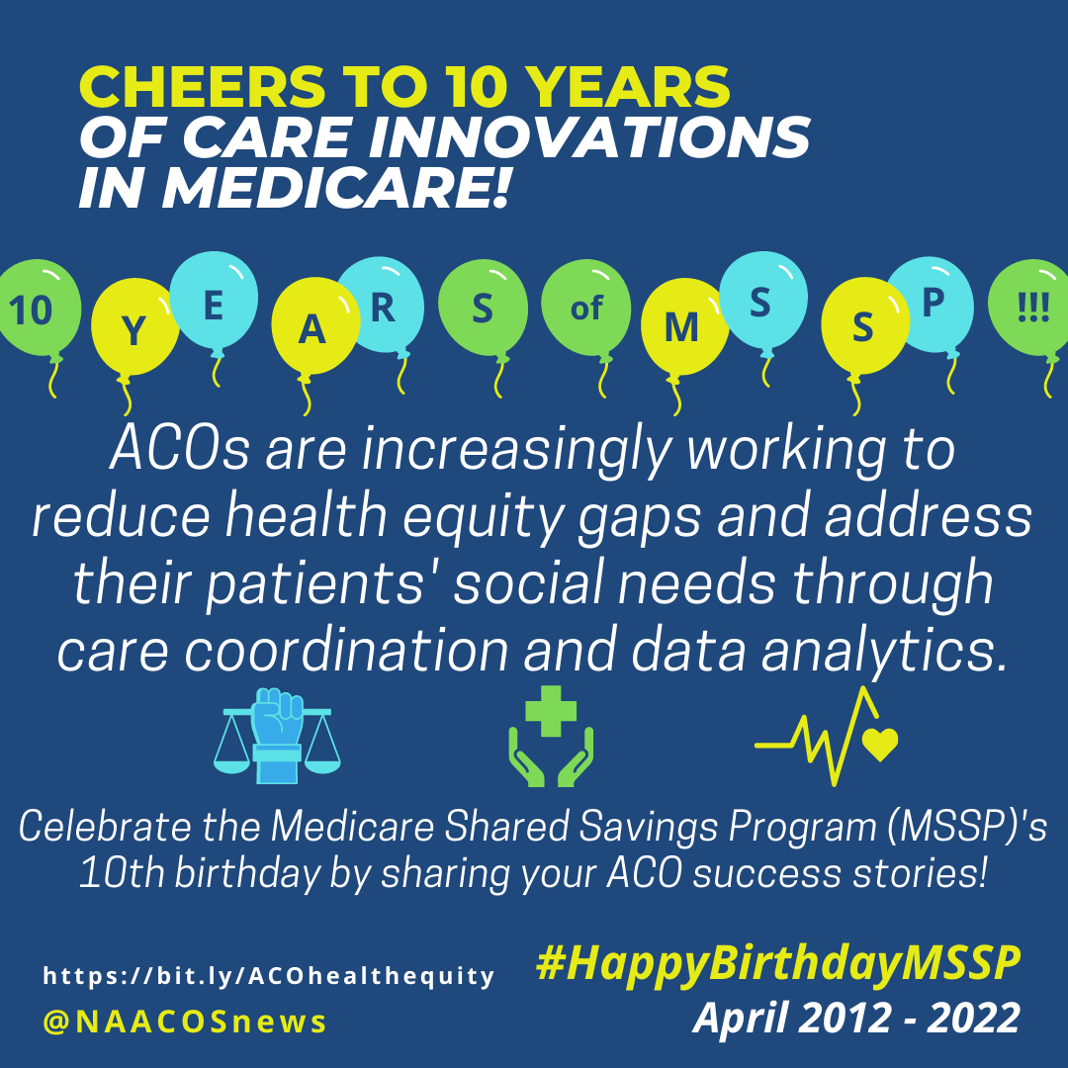
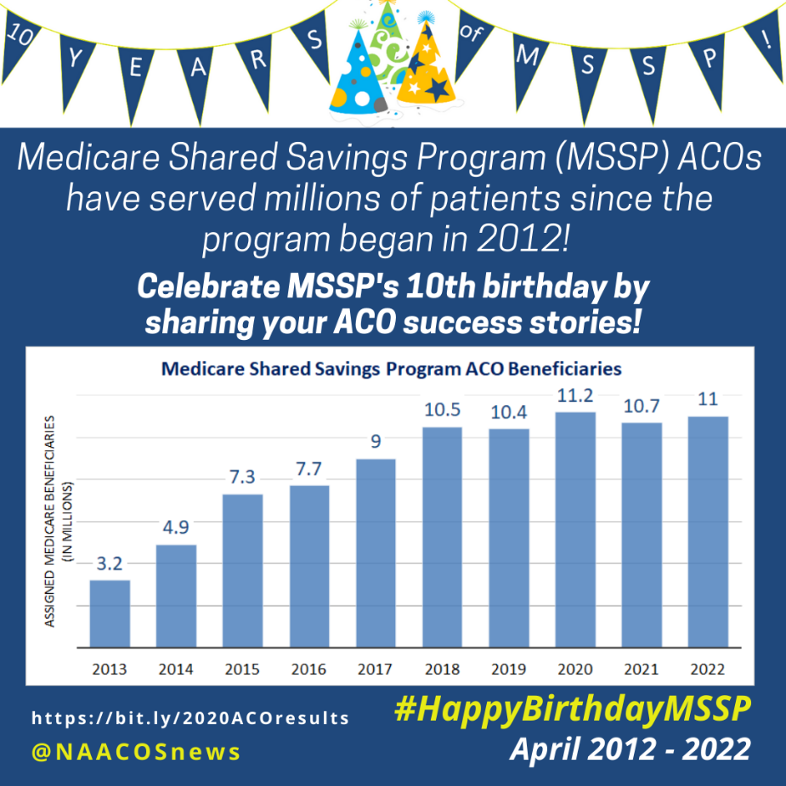
Additional links:
- 2022 Medicare Shared Savings Program (MSSP) Fast Facts: https://www.cms.gov/files/document/2022-shared-savings-program-fast-facts.pdf
- CMS’s press release announcing the 2022 MSSP class: https://www.cms.gov/newsroom/press-releases/medicare-shared-savings-program-continues-grow-and-deliver-high-quality-person-centered-care-through
- CMS’s fact sheet about the first MSSP class in 2012: https://www.cms.gov/newsroom/fact-sheets/first-accountable-care-organizations-under-medicare-shared-savings-program
- Case studies about ACOs using addressing health equity in quality improvement initiatives: https://www.naacos.com/acos-and-health-equity-case-studies

Background:
Section 3022 of the Affordable Care Act added a new section 1899 to the Social Security Act that requires the Secretary to establish the Shared Savings Program. The program is intended to encourage Medicare providers to create a new type of health care entity, an ACO, that agrees to be held accountable for improving the health and experience of care for individuals and improving the health of populations while reducing the rate of growth in health care spending.
On Nov. 2, 2011, CMS published a final rule in the Federal Register establishing the Shared Savings Program. The final rule addressed issues relating to eligibility, governance, beneficiary rights, quality measures and performance scoring, and CMS monitoring of the ACO operations.
Media Inquiries
Contact David Pittman, Senior Policy Advisor, 202-640-2689 or dpittman@naacos.com
About NAACOS
The National Association of ACOs (NAACOS) represents more than 12 million beneficiary lives through hundreds of organizations participating in population health-focused payment and delivery models in Medicare, Medicaid, and commercial insurance. Models include the Medicare Shared Savings Program (MSSP), Global and Professional Direct Contracting Model, and alternative payment models supported by a myriad of commercial health plans and Medicare Advantage. NAACOS is a member-led and member-owned nonprofit organization that works to improve quality of care, outcomes, and healthcare cost efficiency.

